EUROPEAN COMMISSION
HEALTH AND CONSUMERS DIRECTORATE-GENERAL

Safety of the Food chain
Chemicals, contaminants, pesticides

Symbols to label food contact materials

Working document

SANCO E3/FV (15 09 2009)

Note for the reader:
This document contains symbols used to label food contact materials. For each symbol, the reference to the legislation is given.
This document is meant for information.

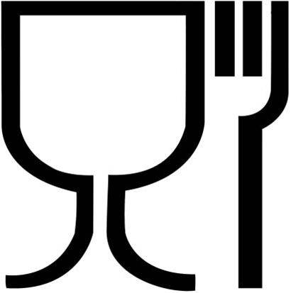

Figure 1: Article 15 of the Framework Regulation (EC) No 1935/2004 on materials and articles intended to come into contact with food specifies the labelling requirements. It says that food contact materials shall be accompanied by the words "for food contact" or this symbol, unless when it is obvious that the article is for food contact.
The size of this symbol is 5x5 cm, it has 300 dpi.

Figure 2: the file here enclosed is the food contact materials symbol and is downloadable as .JPEG file
Figure 3: DO NOT EAT symbol
Article 11 of Regulation (EC) No 450/2009 on active and intelligent materials and articles intended to come into contact with food contains additional rules on labelling. One of these rules is the following:

To allow identification by the consumer of non-edible parts, active and intelligent materials and articles or parts thereof shall be labelled, whenever they are perceived as edible:
(a) with the words ‘DO NOT EAT’; and
(b) always where technically possible, with the symbol reproduced in Annex I.

